PREDICTING DEPRESSION USING MACHINE LEARNING MODELS
COMPE 510: MACHINE LEARNING FOR ENGINEERS
JIYA RATHI
ARKAJIT DUTTA

Introduction

Depression is a prevalent mental health condition that affects millions of individuals worldwide, contributing to significant emotional, psychological, and social burdens. It can manifest through various symptoms such as persistent sadness, lack of interest in activities, and difficulty concentrating, which can interfere with daily functioning and quality of life. In recent years, the importance of early diagnosis and intervention has led to increased interest in using data-driven approaches, such as machine learning (ML), to predict the presence of depression. By analyzing various attributes, such as sleep patterns, social interaction, and physical health, ML models can assist in identifying individuals at risk, and facilitating timely treatment and support.
The application of machine learning in mental health is a promising area of research that can enhance the accuracy and efficiency of diagnosis. Traditional diagnostic methods rely heavily on clinician assessments, but Machine Learning techniques, particularly classification algorithms, offer an opportunity to leverage large datasets with multiple features. These datasets might include demographic information, medical history, and behavioral traits, among others. By training models on such data, researchers aim to uncover patterns that are often overlooked by human evaluators, improving early detection and personalized treatment plans. This approach holds significant potential in reducing the stigma associated with mental health conditions, promoting proactive care, and optimizing resource allocation in healthcare systems.

Related Work

A summarization of the literature –

- A. Ibrahum, K. H. Park, J. -E. Hong, V. -H. Pham and K. H. Ryu, "An Extreme Gradient Boosting-based Prediction for Depression,"
- Song YY, Lu Y. Decision tree methods: applications for classification and prediction. Shanghai Arch Psychiatry. 2015 Apr 25
These two papers provide valuable insights that closely align with our project on predicting depression using machine learning models. In the work by Ibrahum et al. (2023), they utilized an Extreme Gradient Boosting (XGBoost) model combined with hybrid feature selection methods, such as LASSO, to predict depression based on sociological and survey data. This highlights the importance of selecting optimal features to improve model accuracy and reliability. Similarly, Song and Lu (2015) explored decision tree methodologies, offering practical applications for classification and prediction, which are highly relevant to identifying patterns in depression. Together, these studies demonstrate the potential of combining advanced feature selection and robust predictive algorithms to build efficient tools for mental health prediction, inspiring us to take a similar approach in designing our own machine learning model for depression prediction.

A discussion on the difference between your approach from techniques described in the papers you reviewed -

Our approach differs from the techniques described in the reviewed papers through specific customizations to feature handling and model selection tailored to our dataset. While Ibrahum et al. utilized XGBoost with hybrid feature selection methods like LASSO, we chose gradient boosting as our predictive model, favoring a simpler yet highly effective implementation. To address issues of data quality, we removed features with significant missing values instead of imputing them, which allowed us to maintain the integrity and reliability of the dataset. Unlike the broad feature selection strategies in the reviewed works, we focused on extracting the top five most predictive features, prioritizing interpretability and computational efficiency. Additionally, our pipeline emphasized a balance between simplicity and robustness, ensuring that our model captured essential patterns without overfitting. By narrowing our scope and refining our methodology, we were able to create a more streamlined and effective approach to depression prediction.

Problem Formulation
We are provided with a dataset derived from a depression survey. The dataset consists of individual responses to specific attributes or factors (such as age, gender, work-related stress, and lifestyle habits) that are believed to influence mental health. Each data instance represents a person's responses to these factors, along with a binary class label indicating whether the person is diagnosed with depression or not.

Goal:
The objective is to build a predictive machine learning model that can accurately classify individuals as either having depression or not, based on the given attributes. The model should not only perform well in terms of accuracy but also provide insights into the most significant factors contributing to the prediction.

Constraints:
- The dataset is relatively small, which limits the use of highly complex models like deep neural networks.
- The data may contain missing values.
- The features must be pre-processed effectively to ensure consistency and to handle categorical or missing values.
- The model should balance predictive performance and interpretability to ensure practical applicability in real-world mental health settings.
By addressing these factors, the project aims to make meaningful contributions to the use of machine learning in mental health diagnostics.

Methods
Methods Used:

- Gradient Boost Classifier - Gradient Boosting was used in this project to classify individuals as either having depression or not based on survey data. Gradient Boosting is a powerful ensemble learning method that combines weak learners, typically decision trees, to iteratively minimize prediction errors. The model was trained using features extracted from a cleaned dataset after preprocessing steps such as removing missing values and encoding categorical variables with LabelEncoder. The data was split into training and testing subsets, ensuring robust evaluation. Gradient Boosting's ability to handle mixed feature types and prioritize informative features made it suitable for this dataset, achieving a high level of accuracy in prediction.

To improve the model's interpretability and efficiency, feature importance scores were derived from the trained model. The top five most influential features were identified, and the model was retrained using only these features. This reduced feature set maintained high prediction accuracy, demonstrating the model's ability to focus on critical attributes while reducing complexity. By leveraging Gradient Boosting's strengths in feature prioritization and iterative learning, the project highlighted the most significant factors influencing depression predictions, making the results both actionable and insightful for potential mental health applications.
- Decision Tree - In this project, we implemented a Decision Tree Classifier to predict depression status based on survey responses. Decision Trees are a straightforward and interpretable machine learning technique that partitions the dataset into subsets based on feature values. After data preprocessing, including the removal of irrelevant columns and encoding categorical variables, we split the dataset into training and testing sets. The Decision Tree model was trained on the training data and achieved a competitive accuracy on the test set, as evaluated using metrics like the accuracy score and classification report. This method is particularly advantageous due to its ability to capture nonlinear relationships and handle both numerical and categorical data without requiring extensive feature scaling.

We visualized the trained Decision Tree model to enhance understanding and transparency, highlighting the key decision paths and splits. This visualization provided insights into how the model prioritized features to classify individuals as having depression or not. Additionally, we demonstrated how the model could predict new instances of depression status using a custom prediction function. By leveraging the interpretability of Decision Trees, the project not only achieved accurate predictions but also offered meaningful insights into the attributes most associated with depression, making it a useful tool for mental health analysis.
Data Description and Experimental Setup

The dataset used in this project, the Depression Survey Dataset for Analysis available on Kaggle, has been employed in similar ML competitions. This dataset includes several features, such as age, gender, marital status, and responses to psychological questions, which are critical for building predictive models. The dataset has been curated to provide insights into how everyday factors might correlate with mental health risks, making it a useful resource for machine learning models aimed at mental health prediction.

Data source - in tabular form with 2556 rows × 19 columns – 2555 data points with 18 features (19th column is the class label).
Features include:
- 'Name'
- 'Gender'
- 'Age'
- 'City'
- 'Working Professional or Student'
- 'Profession'
- 'Academic Pressure'
- 'Work Pressure'
- 'CGPA'
- 'Study Satisfaction'
- 'Job Satisfaction'
- 'Sleep Duration'
- 'Dietary Habits'
- 'Degree'
- 'Have you ever had suicidal thoughts?'
- 'Work/Study Hours'
- 'Financial Stress'
- 'Family History of Mental Illness'
Experimental Setup -
Data preprocessing began with handling missing values and encoding categorical features. A covariance matrix was used to identify highly correlated features to enhance feature selection, allowing us to retain only the most impactful predictors and minimize redundancy. This approach aimed to improve model performance while reducing noise in the dataset.
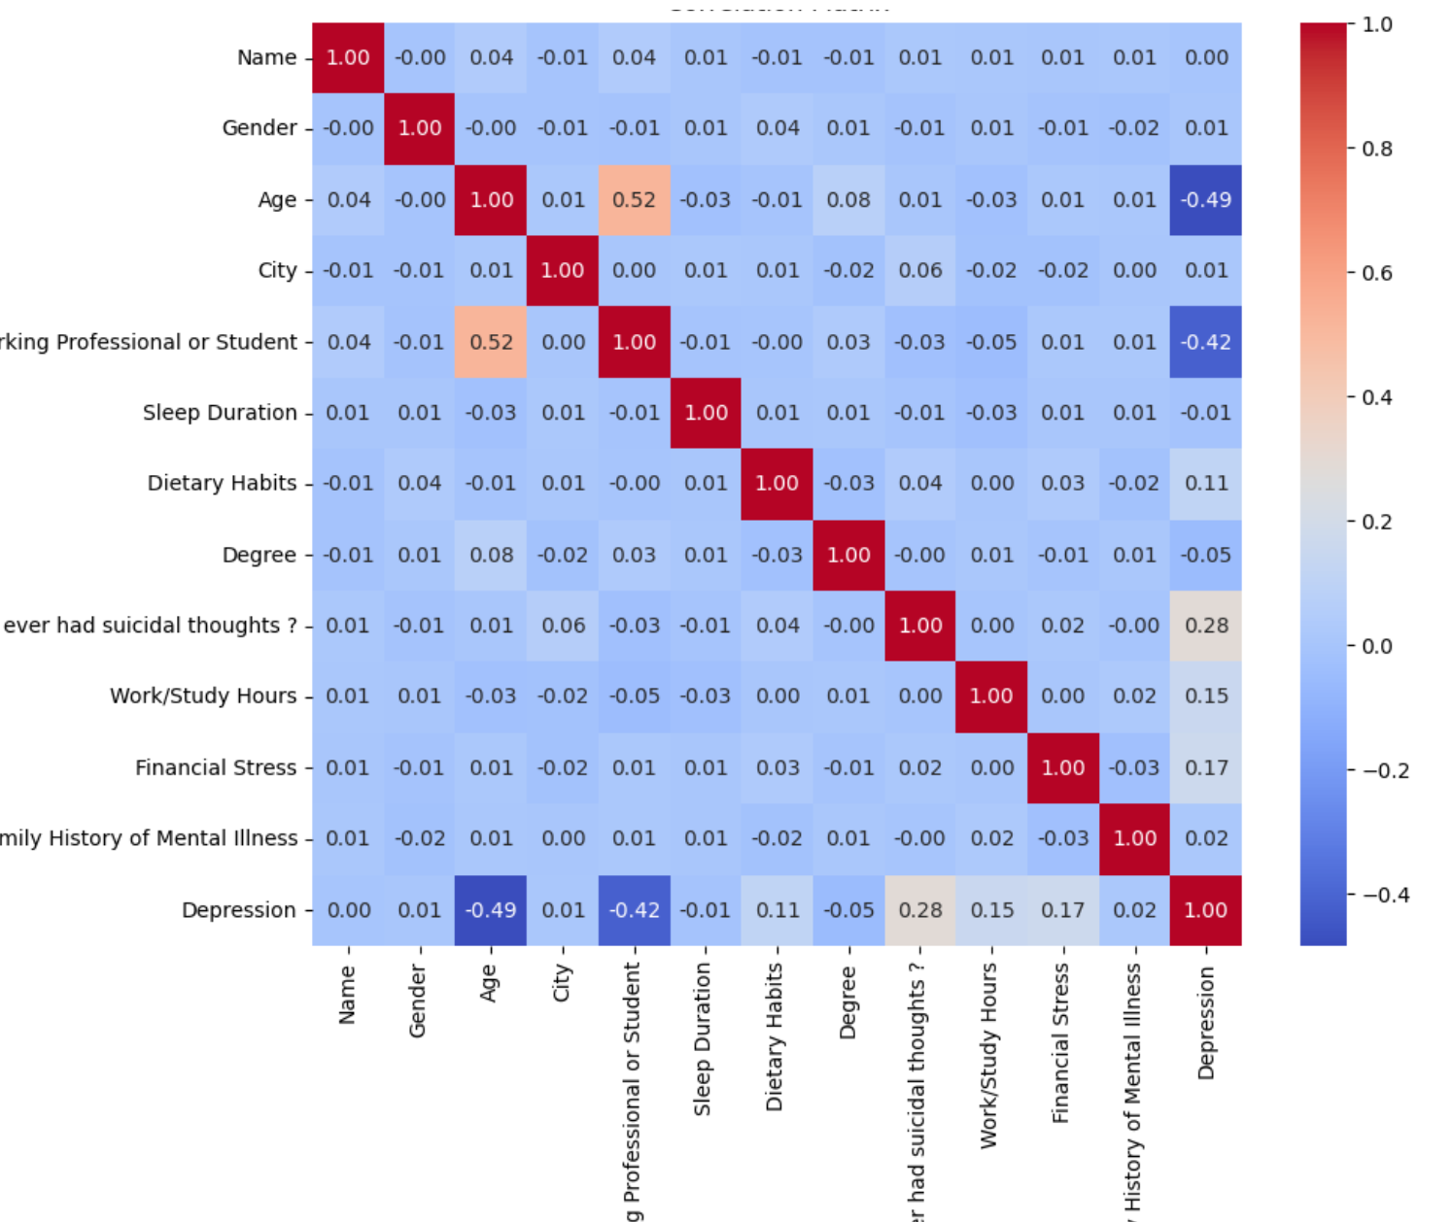
As our survey data consisted of individuals of all ages, some features had missing data. For example, a student would not have any data for features - 'Job Satisfaction', 'Profession', or 'Work Pressure'. Similarly, a working individual would not have information for academia-related fields - 'Academic Pressure', 'CGPA', and Study Satisfaction'. Through data pre-processing, we found the following columns to be inconsistent and thereby did not consider them during model training and testing:

Column 'Profession': 673 NaN values
Column 'Academic Pressure': 2054 NaN values
Column 'Work Pressure': 502 NaN values
Column 'CGPA': 2054 NaN values
Column 'Study Satisfaction': 2054 NaN values
Column 'Job Satisfaction': 502 NaN values

Models were trained with default hyperparameters using the sci-kit-learn library with the random state set to 42 for reproducibility. A train-test split of 70-30 was employed, ensuring robust evaluation. The feature importance scores generated by the Gradient Boosting model guided the selection of the top five features, leading to a refined model with improved interpretability. The Decision Tree Classifier was similarly implemented, with an emphasis on visualizing the decision-making process through tree diagrams, which highlighted the influence of key features.
Both models were evaluated using accuracy, with Gradient Boosting offering insights into feature interactions and decision trees providing an intuitive understanding of predictions. This dual approach enabled an in-depth analysis of the factors contributing to depression predictions.
Experimental Results and Analyses

The experimental analysis aimed to predict the likelihood of depression based on a dataset with 18 attributes, narrowed down to five key features: Age, Have you ever had suicidal thoughts?, Working Professional or Student, Financial Stress, and Work/Study Hours. Two machine learning classifiers, Gradient Boosting, and Decision Tree, were employed to assess their predictive performance. Below, we discuss the results and insights derived from these experiments.

Gradient Boosting Classifier
The Gradient Boosting model achieved an accuracy of 88.87%, with a precision of 0.93 and a recall of 0.94 for the non-depression class. For the depression class, the precision was 0.65, and the recall was 0.62, leading to an overall F1-score of 0.64. The confusion matrix indicates that the model correctly classified 603 out of 647 instances as non-depressed and 80 out of 120 instances as depressed, with 44 and 40 misclassifications, respectively.

Decision Tree Classifier
The Decision Tree model yielded a slightly lower accuracy of 87.22%, with a precision of 0.93 and a recall of 0.92 for the non-depression class. For the depression class, it achieved a precision of 0.59 and a recall of 0.61, resulting in an F1-score of 0.60. From the confusion matrix, the Decision Tree correctly identified 596 out of 647 non-depressed instances and 73 out of 120 depressed instances. It misclassified 51 and 47 instances from these groups, respectively.

Observations and Insights

The Gradient Boosting Classifier outperformed the Decision Tree in terms of both overall accuracy and its ability to identify depressed individuals (depression class) correctly. This improvement can be attributed to the following factors:

Boosting Mechanism: Gradient Boosting leverages an ensemble of weak learners (decision trees) and iteratively refines predictions by minimizing errors from previous iterations. This adaptive nature allows the model to handle complex relationships in the data more effectively than a standalone decision tree.
Overfitting Resistance: Decision trees are prone to overfitting, especially with small datasets or imbalanced class distributions. In contrast, Gradient Boosting employs regularization techniques to mitigate overfitting, resulting in better generalization.
Feature Interactions: Gradient Boosting can capture intricate relationships between features like age, financial stress, and work hours, which may significantly influence the prediction of depression.

Despite these advantages, the Decision Tree model demonstrated some strengths:

Interpretability: Decision Trees provide a clear, interpretable structure, which could be valuable in scenarios requiring transparency, such as healthcare applications.
Performance on Non-Depression Class: The Decision Tree performed comparably to Gradient Boosting for the majority class (non-depression), with a slight trade-off in the minority (depression) class.
Potential Scenarios for Better Decision Tree Performance

The Decision Tree might have performed better under the following conditions:

Balanced Dataset: The current dataset exhibits an imbalance between the depression (minority) and non-depression (majority) classes. Addressing this imbalance through resampling techniques (e.g., SMOTE or under sampling) could improve the decision tree’s performance in the minority class.
Feature Selection: Decision Trees are sensitive to irrelevant or noisy features. Additional feature engineering or removing less impactful attributes could enhance its performance.
Hyperparameter Optimization: Further tuning of the Decision Tree's hyperparameters, such as maximum depth, minimum samples per leaf, or criterion, could improve its predictive power.

Conclusion

In this study, we analyzed the effectiveness of Gradient Boosting and Decision Tree classifiers in predicting depression based on five key attributes. The results demonstrated that Gradient Boosting outperformed the Decision Tree with an accuracy of 88.87% compared to 87.22%, offering better precision and recall for the depression class while maintaining strong performance for the non-depression class. The ensemble-based nature of Gradient Boosting allowed it to capture complex feature interactions and resist overfitting, which likely contributed to its superior performance. On the other hand, the Decision Tree provided comparable accuracy for the majority class and remains a valuable option when interpretability is crucial. These findings underscore the importance of selecting appropriate models based on the dataset characteristics and the application's specific requirements, such as accuracy, balance, and transparency.

Attached below is a side-by-side comparison of the two methods and their resulting accuracy displayed in the form of a confusion matrix and Classification Report.

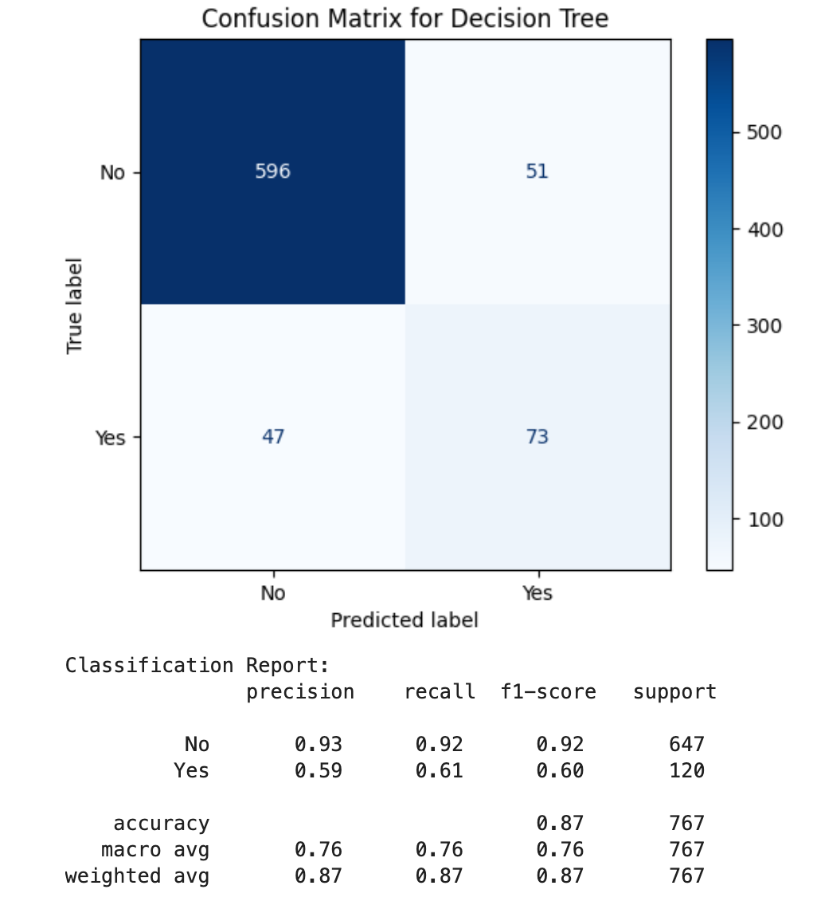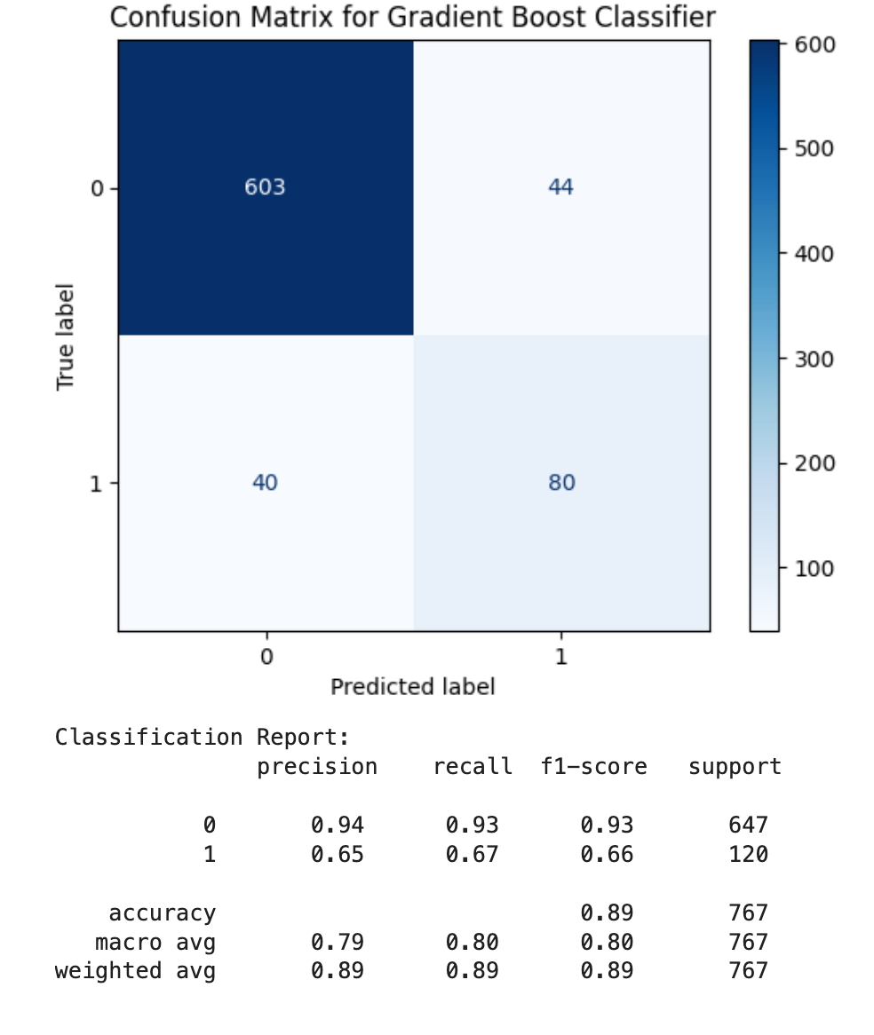
Decision Tree Gradient Boost Classification

Interactive Predictive Model

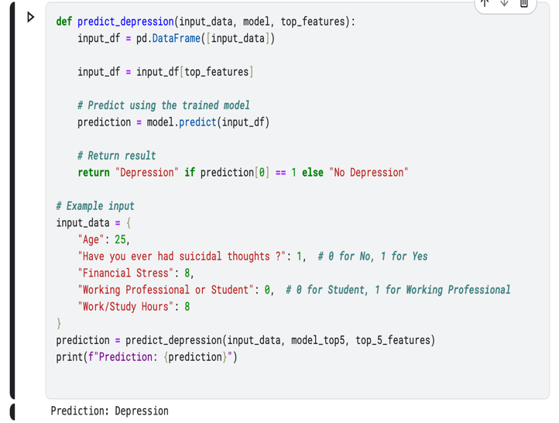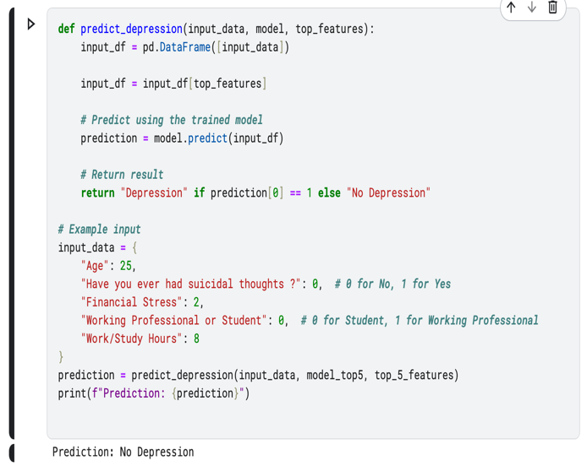
Model predicting “No Depression” for Model predicting “Depression” for
Input data = {"Age":25, Input data = {“Age”:25,
"Have you ever had suicidal thoughts?": 1 "Have you ever had suicidal thoughts?": 0,
"Financial Stress": 8, "Financial Stress": 2,
"Working Professional or Student": 0 "Working Professional or Student": 0
"Work/Study Hours": 8} "Work/Study Hours": 8}

Reference

A. Ibrahum, K. H. Park, J. -E. Hong, V. -H. Pham and K. H. Ryu, "An Extreme Gradient Boosting-based Prediction for Depression," 2023 Asia Pacific Signal and Information Processing Association Annual Summit and Conference (APSIPA ASC), Taipei, Taiwan, 2023, pp. 1607-1613, doi: 10.1109/APSIPAASC58517.2023.10317543. keywords: {Surveys;Input variables;Sociology;Hafnium;Predictive models;Depression;Feature extraction;machine-learning;Depression;Hybrid Feature Selection;LASSO;XGBoost},

Song YY, Lu Y. Decision tree methods: applications for classification and prediction. Shanghai Arch Psychiatry. 2015 Apr 25;27(2):130-5. doi: 10.11919/j.issn.1002-0829.215044. PMID: 26120265; PMCID: PMC4466856.

Individual contributions

Jiya - the entirety of Decision Tree section, Data Pre-Processing
Arkajit - the entirety of Gradient Boost Classification section, Data Visualization

